Multiple-choice section – choose the correct answer

Question 1 [8.1]

An angle of 285° is:

A acute B reflex C obtuse D a right angle

Question 2 [8.1]

Corresponding angles on parallel lines:

A are complementary B are supplementary

C are equal D add to 360°

Question 3 [8.4]

The two triangles in the shape are congruent. Which test proves this?

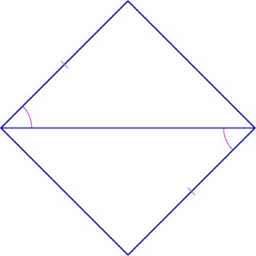

A SAS B ASA C SSS D RHS

Question 4 [8.2]

Find the value of the pronumeral *x*.

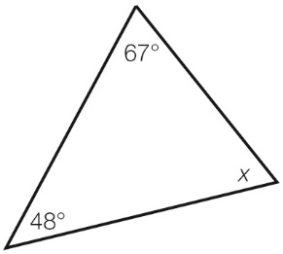

A 115° B 65° C 67° D 245°

Question 5 [8.3]

Congruent figures have:

A same shape and different size B different shape and size

C same shape and size D different shape and same size

Question 6 [8.2]

Which list contains only quadrilaterals?

A square, rhombus, trapezium B rectangle, pentagon, parallelogram

C square, polygon, rectangle D kite, trapezium, hexagon

Question 7 [8.2]

The name given to a polygon with 12 sides is a:

A hexagon B decagon C octagon D dodecagon

Question 8 [8.2]

Which statement is true for a kite?

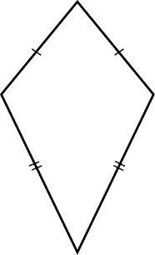

A diagonals bisect each other at right angles B all angles are right angles

C the shape has no side or diagonal properties D diagonals intersect at right angles

Multiple-choice results: \_\_\_ /8

Short answer section

Question 9 2 marks [8.2, 8.3]

Choose the correct words from the list to fill each of the gaps in the following sentences.

*triangle kite rectangle translation reflection rotation*

(a) A \_\_\_\_\_\_\_\_\_\_\_\_\_\_\_ has both pairs of opposite sides equal in length.

(b) Another name for a slide is a \_\_\_\_\_\_\_\_\_\_\_\_\_\_\_\_.

Question 10 2 marks [8.1]

State if each of the following pairs of angles is complementary (add to 90°) or   
supplementary (add to 180°).

(a) 44° and 46° \_\_\_\_\_\_\_\_\_\_\_\_\_\_\_\_\_\_\_\_\_\_\_\_\_\_

(b) 21° and 159° \_\_\_\_\_\_\_\_\_\_\_\_\_\_\_\_\_\_\_\_\_\_\_\_\_

Question 11 3 marks [8.5]

The parallelogram below is made up of two congruent triangles, *ABC* and *CDA*.

Find the value of the angles *x, y* and *z*.

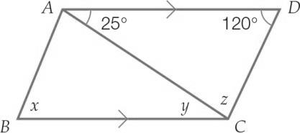

Question 12 4 marks [8.1]

Find the value of the pronumeral in each diagram by completing the steps given. Give reasons for your answer.

(a)

|  |  |
| --- | --- |
| PM8_SmB_8_05tf_RR | *x* + \_\_\_\_\_\_\_\_\_\_ = \_\_\_\_\_\_\_\_\_\_\_\_  *x* =  Reason: |

(b)

|  |  |
| --- | --- |
| C:\Users\ubuluay\Desktop\2nd ed\PM2e-8-ch-tests-exams-RWs\_SUPPLIED_V1_CORREX_230916\PM2e_08_EB_08_FAT_03.jpg | *x* + \_\_\_\_\_\_\_\_\_\_ + \_\_\_\_\_\_\_\_\_\_ = \_\_\_\_\_\_\_\_\_\_\_\_  *x* =  Reason: |

Question 13 2 marks [8.1]

Find the value of the angle *x* in the diagram. Give one of the following reasons:   
co-interior angles on parallel lines; corresponding angles on parallel lines; alternate angles on parallel lines.

|  |  |
| --- | --- |
| PM8_SmB_8_07tf_RR | *x* =  Reason: |

Question 14 2 marks [8.1]

Find the value of the angle *a* in the diagram. Give one of the following reasons: adjacent angles or vertically opposite angles.

|  |  |
| --- | --- |
| PM8_SmB_8_08tf_RR | *a* =  Reason: |

Question 15 4 marks [8.2]

Find the value of the pronumerals, giving your reasons.

|  |  |
| --- | --- |
| (a)  PM8_SmB_8_10tf_RR | (b)  PM8_SmB_8_11tf_RR |

Question 16 3 marks [8.2]

(a) Divide the octagon into triangles with no overlapping lines. How many triangles are there?

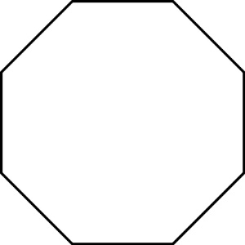

(b) If one triangle has an interior angle sum of 180°, what is the angle sum of a regular octagon?

Question 17 6 marks [8.3]

(a) What does the translation [6, -4] mean?

(b) Perform the translation of [6, -4] on the shape *ABCD* and label the points of the transformed quadrilateral *A*′*B*′*C*′*D*′.

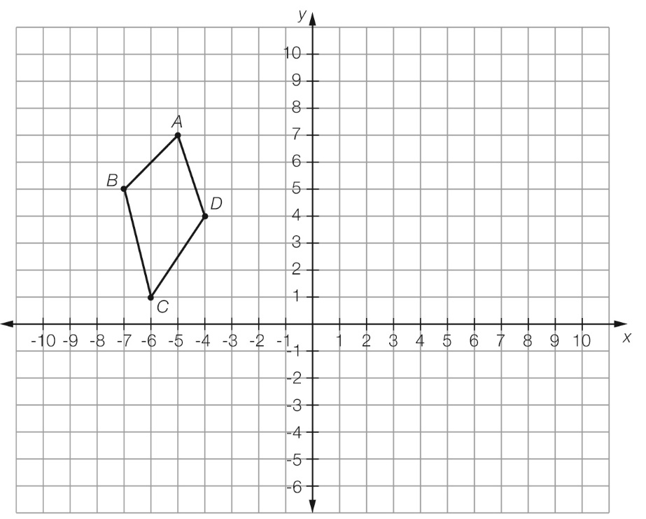

(c) What are the coordinates of the transformed quadrilateral?

*A*′ \_\_\_\_\_\_\_\_\_\_\_\_ *B*′ \_\_\_\_\_\_\_\_\_\_\_\_ *C*′ \_\_\_\_\_\_\_\_\_\_\_\_ *D*′ \_\_\_\_\_\_\_\_\_\_\_\_

Question 18 6 marks [8.3]

(a) Reflect the quadrilateral shown below in the *y*-axis and label the points of the transformed quadrilateral *A*′*B*′*C*′*D*′.



(b) What are the coordinates of the transformed quadrilateral?

*A*′ \_\_\_\_\_\_\_\_\_\_\_\_ *B*′\_\_\_\_\_\_\_\_\_\_\_\_ *C*′\_\_\_\_\_\_\_\_\_\_\_\_ *D*′ \_\_\_\_\_\_\_\_\_\_\_\_

Question 19 2 marks [8.5]

The figure below is a parallelogram. Name any two pairs of congruent triangles.

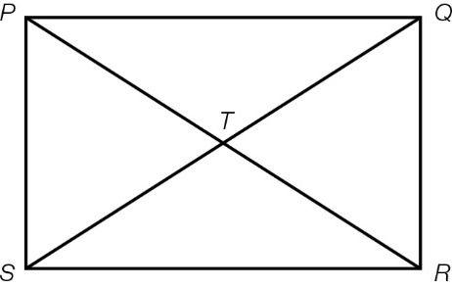

Question 20 2 marks [8.5]

The two quadrilaterals are congruent. Use your knowledge of matching angles and side lengths to find the value of the pronumerals.

|  |  |
| --- | --- |
| PM8_SmB_8_18tf_RR | *x* = \_\_\_\_\_\_\_\_\_\_\_\_\_\_\_ m  *y* = \_\_\_\_\_\_\_\_\_\_\_\_\_\_\_\_° |

Question 21 2 marks [8.4]

Use congruent triangles and known angle facts to find the value of the pronumeral in the quadrilateral. Give reasons for your answer.

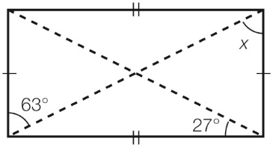

Short answer results: \_\_\_ / 40

Extended answer section

Question 22 4 marks [8.2]

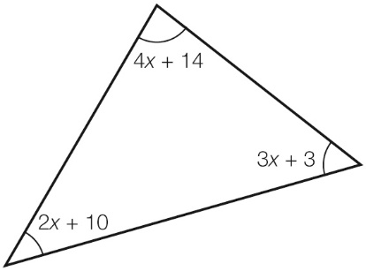

(a) Find the value of *x*.

(b) Find the size of each angle.

Extended answer results: \_\_\_ / 4

TOTAL test results: \_\_\_ / 52